Student Name: **Hongyao Tao (001067209)**

**INFO 6205**

**Program Structures & Algorithms**

**Spring 2021**

**Assignment No.2**

* **The implement of three methods of Timer class and test result**

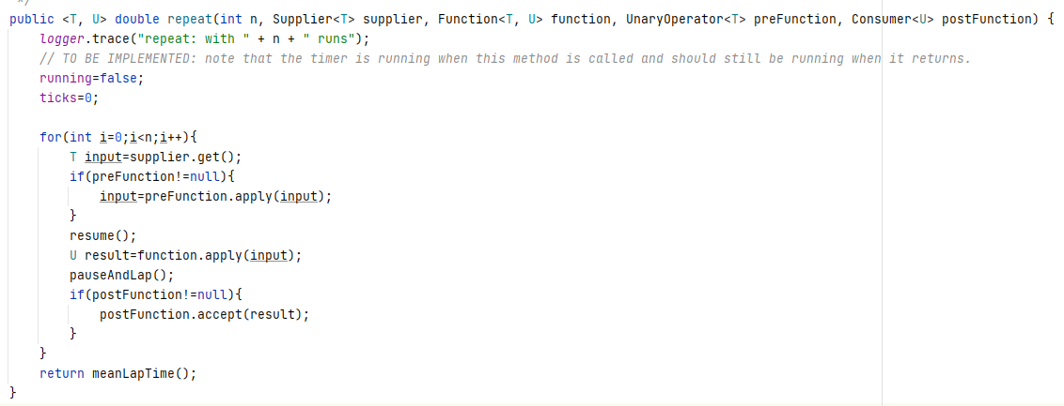

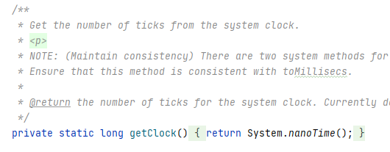

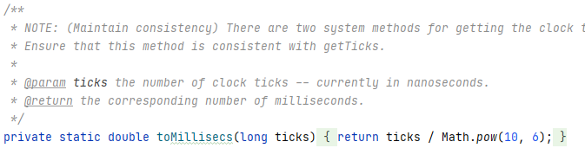

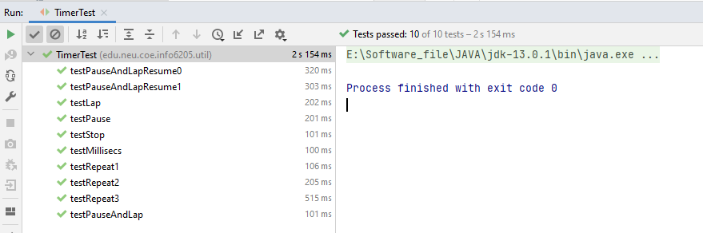

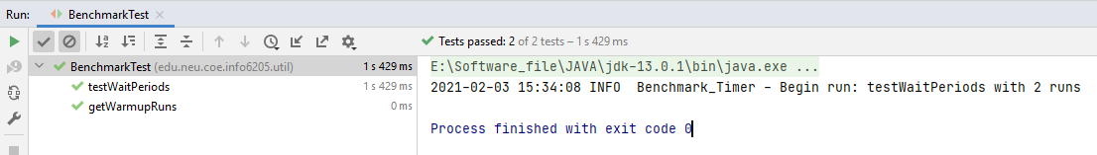

**Figure 1. The test result of Timer class**

* **The implement of insertionSort class and test result**

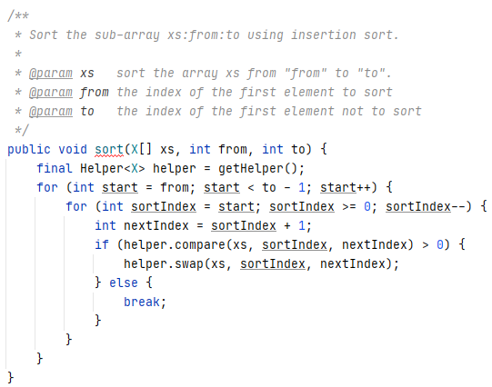

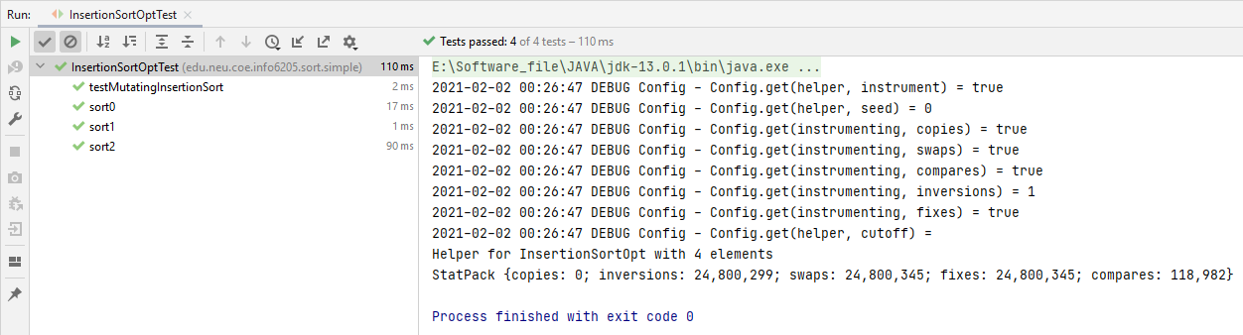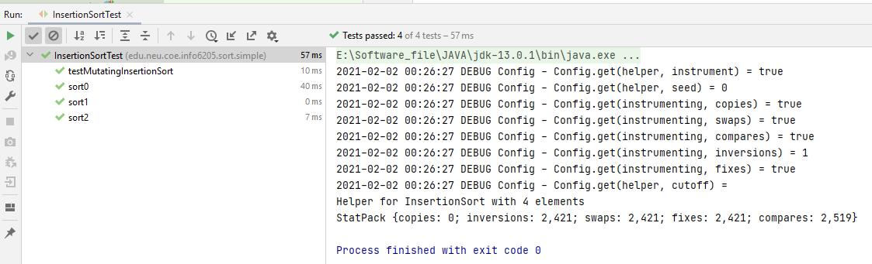

**Figure 2. The Test result of insertion sort class**

* **The implement of unit test for insertion sort benchmarks on different input data**

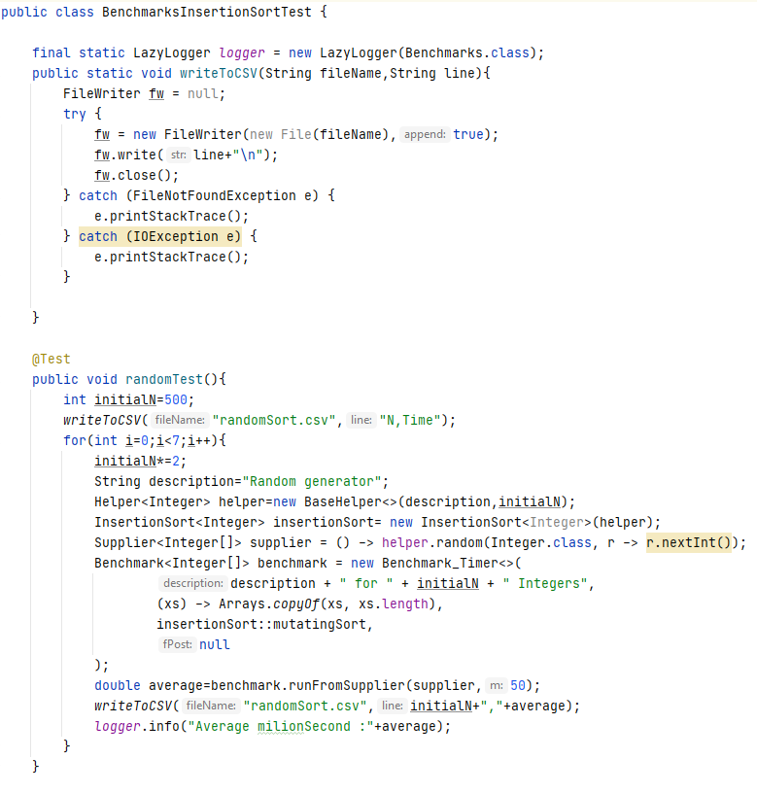

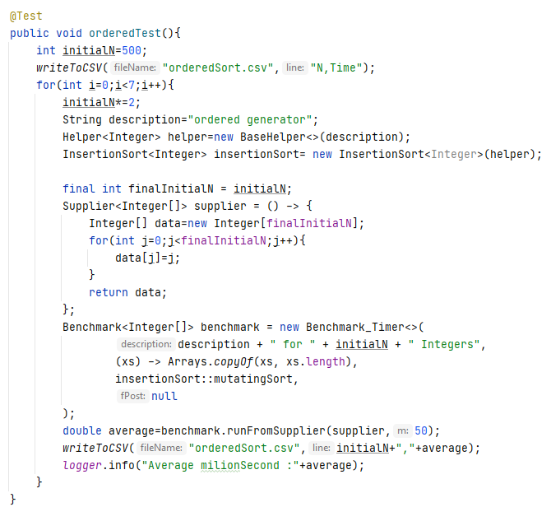

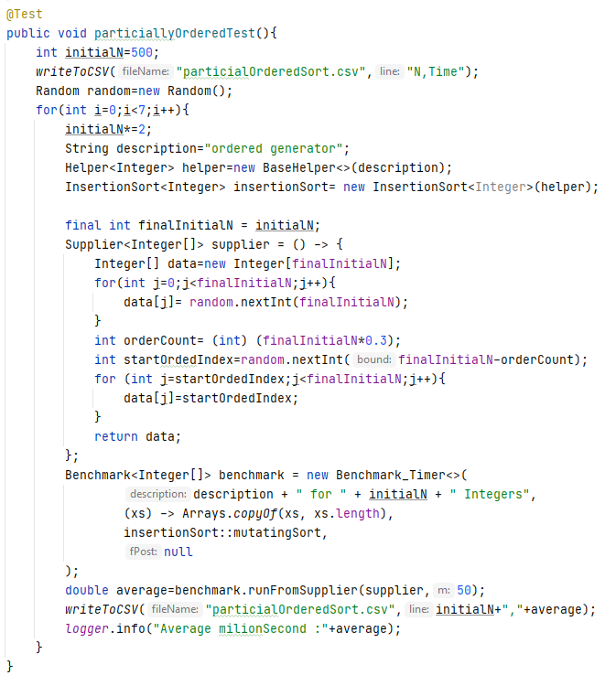

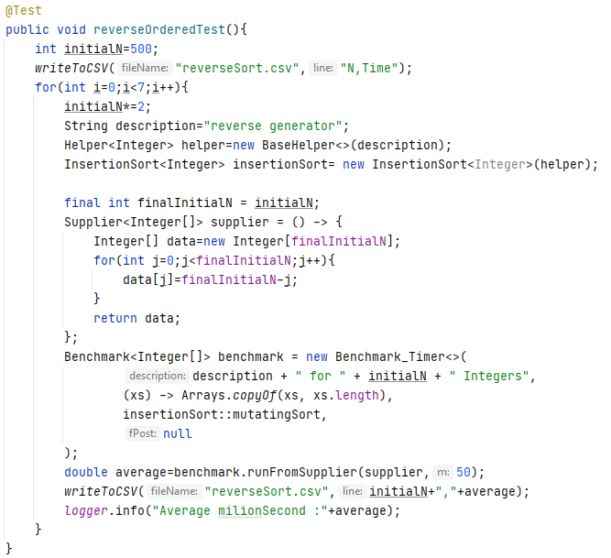

* **Conclusion**

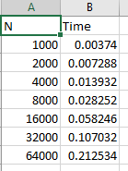 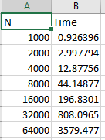 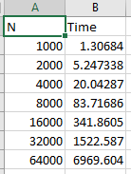 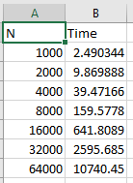

**Figure 3. The T/N grow result on ordered, partial ordered, random and reversed input**

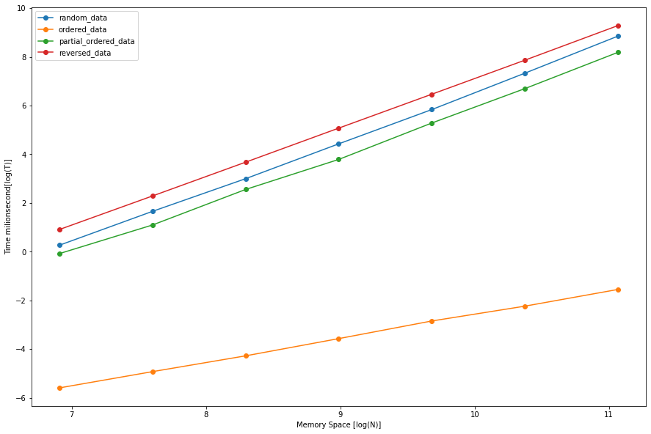

**Figure 4. The insertion sort T/N grow logarithm graph**

According the insertion sort logarithm graph, when the input data is reversed, the cost of time is biggest which is more than the cost of time on random data. Besides, time cost of sorting random data is a bit more than sorting partial ordered data. When the input data is ordered, this sorting algorithm has the minimal time cost which is far less three previous situations. In addition, this sorting algorithm has liner increasement on this logarithm graph, which means that the subtraction of log(T2) and log(T1) is constant that is log(T2)-log(T1) ~ log(2N*(2N+1)/2)- log(N*(N+1)/2) ~ log 4.